DBS311NEE L08 Answers and outputs

**Name: Wei-Chih Kao  
ID: 158000190  
Date: Nov. 24. 2021**

Task1  
Write a query to return *name* and *price* of each product in the *inventory* database.

> db.products.find({}, {"_id":0, "name":1, "price":1})

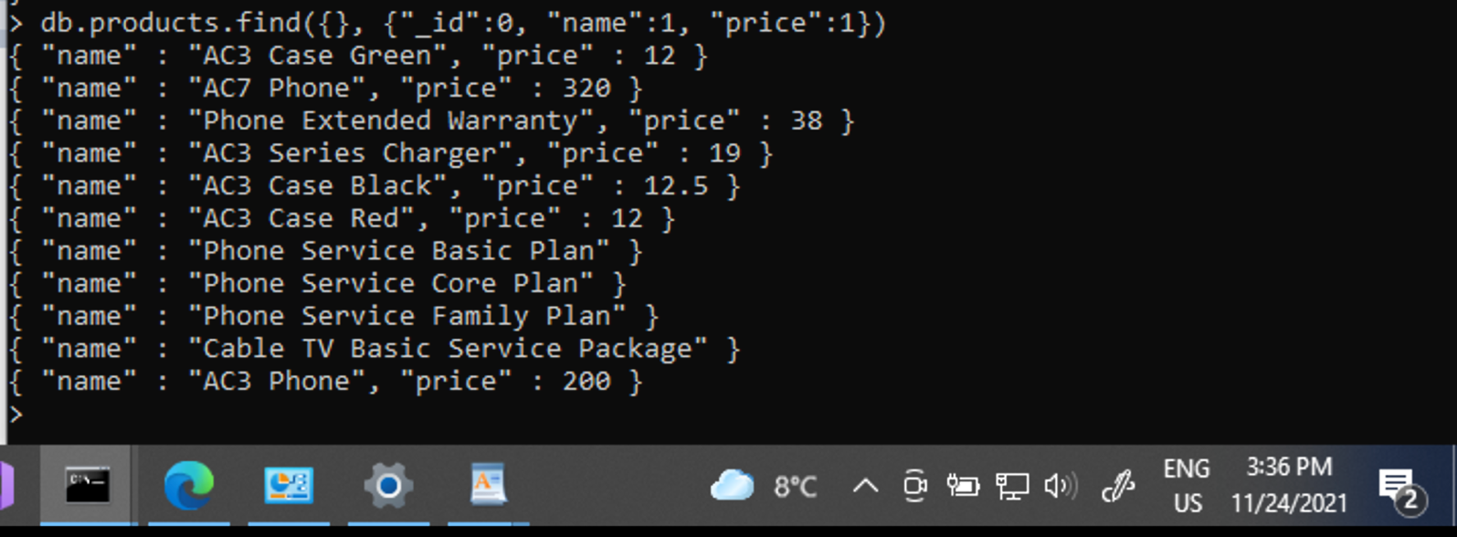

Task2  
Write a query to return *name* and *price* for products of type *accessory* in the *inventory* database.

> db.products.find({type:"accessory"}, {"_id":0, "name":1, "price":1})

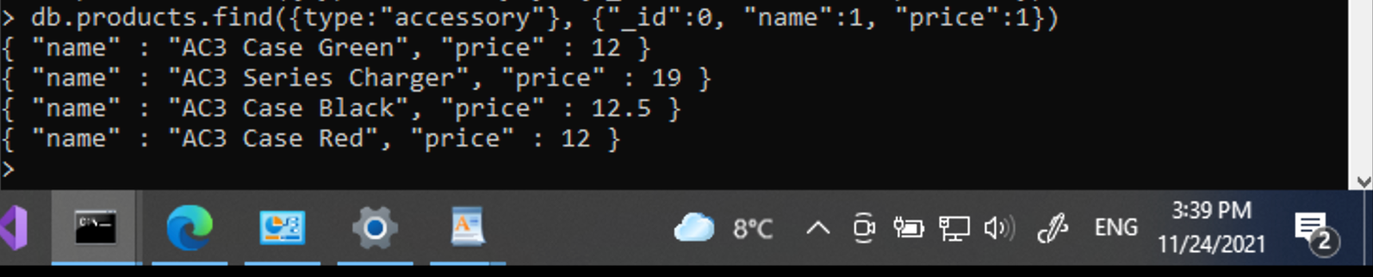

Task3  
Write a query to return name and price for products with price between $12 and $20 (Values 12 and 20 are included).

> db.products.find({price:{$gte:12, $lte:20}}, {"_id":0, "name":1, "price": 1})

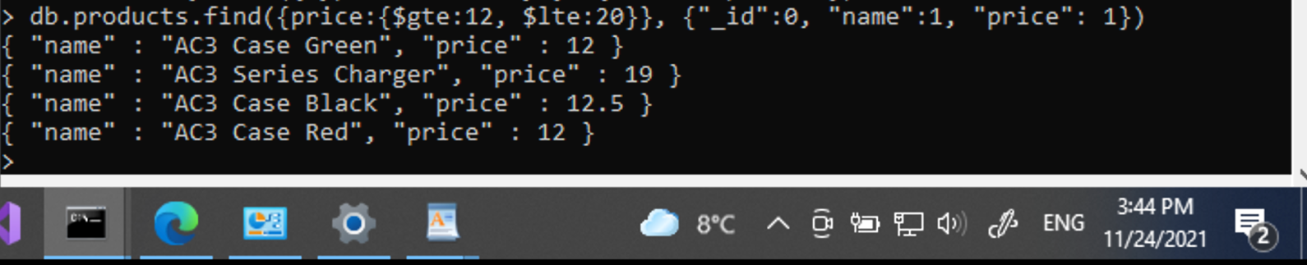

Task4  
Write a query to return id, name, price, and type for products that are not of type accessory.

> db.products.find({type:{$ne:"accessory"}}, {id:1, name:1, price:1, type:1})

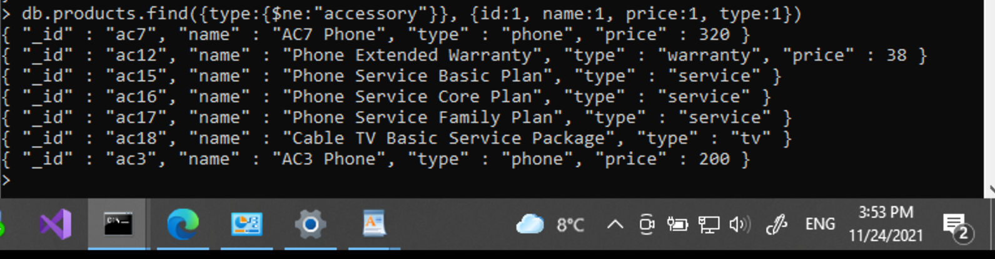

Task5  
Write a query to return id, name, price, and type for products with type accessory or service.

> db.products.find({$or: [{type:"accessory"},{type:"service"}]}, {id:1, name:1, price:1, type:1})

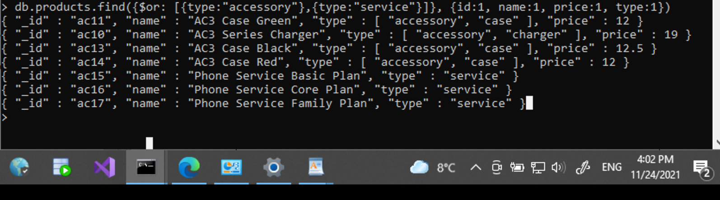

Task6  
Write a query to return id, name, price, and type for products that do have the type key.

> db.products.find({type:{$exists:true}}, {name:1, price:1, type:1})

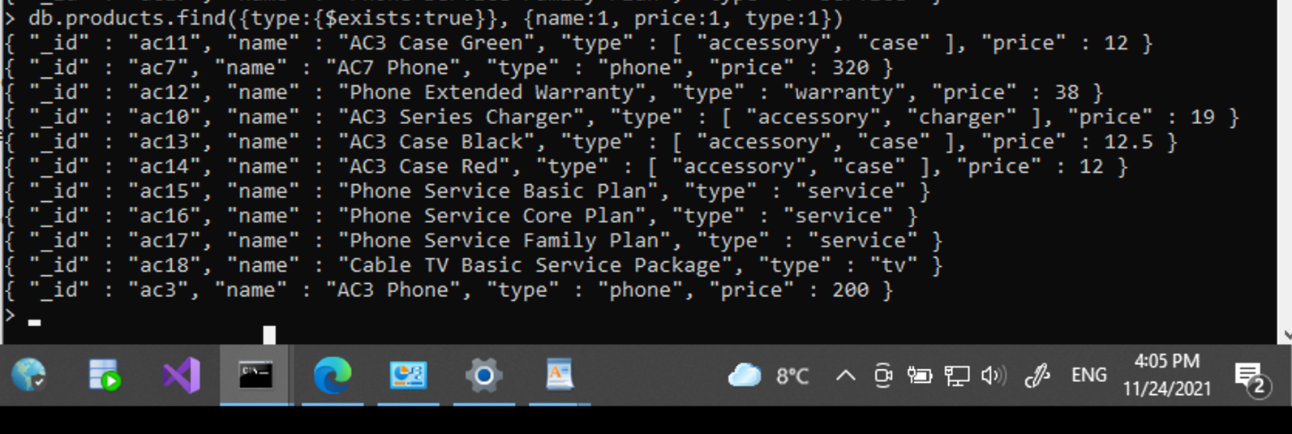

Task7  
Write a query to return id, name, price, and type for products that their type is both accessory and case.

> db.products.find({type: {$all:["accessory", "case"]}}, {id:1, name:1, price:1, type:1})

